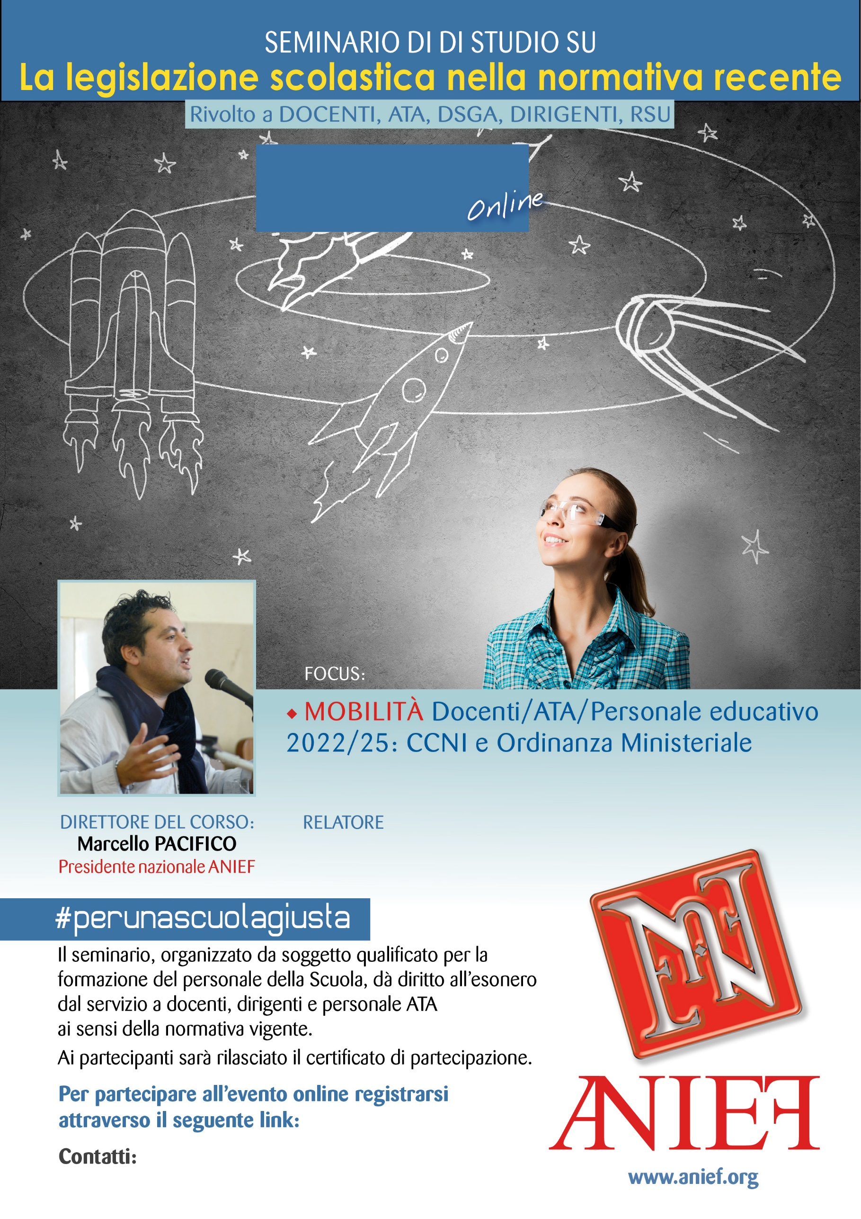

LINK DIRETTA: <https://anief.org/as/RW2M>

[friuliveneziagiulia@anief.net](file:///C:\Users\gi.mistretta\Downloads\seminari%20file%20editabili\friuliveneziagiulia@anief.net)

GIOVANNI PORTUESI

SICILIA PALERMO/AGRIGENTO/TRAPANI

09/03/2022 ORE 08:15 – 10:15